Class Interfaces
a)game Package

1.public abstract class Character

Properties

private String name:
This is name of the Character
This property is private because it is only intended to access by setter and getter methods provided

private Location current:
This is the current location of the Character
This property is private because it is only intended to access by setter and getter methods provided

private List<Item> items:
This is the list of items that character has
This property is private because it is only intended to access by setter and getter methods provided

private int hitpoint:
Remaining hit-points of the Character
This property is private because it is only intended to access by setter and getter methods provided

Constructors

public Character( String name,List<Item> inventory,int x,int y);
@param name String name to assign to character
@param inventory List of Items Character has
@param x Location of the Character
@param y Location of the Character
name and inventory will be initialized. current Location of the Character will be set according to x and y
Methods
public String attack(Character target,Item item);
Player attacks given target with the given item if it is possible, result given with an appropriate string message Damage will be calculated according to users stats, and equipment This method designed to be called from Player object inside Game object inside Parser object game.player.attack(character,item);
@param target to Attack
@param Item to use while attacking
public String getName();
Getter method for the property name
@return name as a String
public Location getLocation();
Getter method for the property Location
@return current Location of the Character
public List<Item> getItems()
Getter method for the property items
@return items as a List<Item> object
public int getHitPoints()
Getter method for the property hitpoint
@return hitpoint Integer
2.public abstract class NonPlayerCharacter extends Character

Constructors
public NonPlayerCharacter( String name,List<Item> inventory,int x,int y);
@param name String name to assign to character
@param inventory List of Items Character has
@param x Location of the Character
@param y Location of the Character
This will call the super constructor with the given parameters
3.public class HostileCharacter extends NonPlayerCharacter
Properties
private boolean awake:
this boolean shows that hostile character is aware of the presence of the player, and it will attack to player with the each action player does.
This property is private because it is only intended to access by setter and getter methods provided
Constructors
public NonPlayerCharacter( String name,List<Item> inventory,int x,int y);
@param name String name to assign to character
@param inventory List of Items Character has
@param x Location of the Character
@param y Location of the Character
This will call the super constructor with the given parametersMethods
Methods
public boolean getAwake()
Getter method for the property awake
@return awake as a boolean
public void setAwake(boolean newAwake)
Setter method for the property awake
sets the awake boolean accordingly

4.public class Player extends Character

Properties

private String seed:
This is the seed of the Player, all randomness will be according to this value, this way players will be able to challenge other players on same generation, also they will be able to play to play on the same world again
This property is private because it is only intended to access by setter and getter methods provided
private int fullness:
This is the hunger level of the Player, it is designed as fullness to make it parallel with other stats, this number will decrease with every action player does, when it hits zero player will starve
This property is private because it is only intended to access by setter and getter methods provided

private int heat:
This is the heat level of the player, this will change according to surrounding temperature. Player is forced to find some heat source in order to survive nights
This property is private because it is only intended to access by setter and getter methods provided

private int strength:
This is the strength stat of the player, this number will act as a multiplier when calculating the damage output of his/her atacks. Player's strength may increase according to tasks done, or decrease with hunger, etc.
This property is private because it is only intended to access by setter and getter methods provided

private int sanity:
This is the sanity level of the player, It will decrease in dark (night,dungeons,etc.) and will increase if player has no hunger, heat problem during daytime. If this number goes too low, game will be over
This property is private because it is only intended to access by setter and getter methods provided

Constructors

public Player(String name, List<Item> inventory, int x, int y);
@param name String name to assign to Player
@param inventory List of Items Player has
@param x Location of the Player
@param y Location of the Player
This will call the super constructor with the given parameters
Methods
public String go(Direction direction);
@param direction to move
@return resulting String message
Player moves according to given direction if it is possible

public String interact(Thing thing);
@param thing to interact
@return resulting String message
Player interacts with given Thing if it is possible
public String use(Item item);
@param item to use
@return resulting String message
Player uses given Item if it is possible
public String take(Item item);
@param item to take
@return resulting String message
Player takes given Item if it is possible, if successful Item will be added to players inventory.
public String look(Direction direction);
@param direction to look
@return resulting String message
Player looks to given direction if it is possible
public String inspect(Thing thing);
@param thing to inspect
@return resulting String message
Player inspects given thing if it is possible,Reader will understand look Thing, as inspect Thing
public String getSeed();
@return seed as String
Getter method for the property seed
public void setFullness(int fullness);
@param fullness to set
Setter method for the property fullness
public int getFullness();
@return fullness as int
Getter method for the property fullness

public void setHeat(int heat);
@param heat to set
Setter method for the property heat
public int getHeat();
@return heat as int
Getter method for the property heat

public void setStrength(int strength);
@param strength to set
Setter method for the property strength
public int getStrength();
@return strength as int
Getter method for the property strength

public void setSanity(int sanity);
@param sanity to set
Setter method for the property sanity
public int getSanity();
@return sanity as int
Getter method for the property sanity

5.public interface Thing
Methods
public String getMessage();
@return String message to be displayed
This methods returns the message to be send when interacted with the object itself

public String interact();
@return String message to be displayed
A method to interact with the Thing

6.public class Furniture implements Thing
Methods
public String getMessage();
@return String message to be displayed
This methods returns the message to be send when interacted with the object itself
Methods
public String interact();
@return String message to be displayed
A method to interact with the Furniture
7.public class Item implements Thing

Properties
private String name:
This is name of the Item
This property is private because it is only intended to access by setter and getter methods provided

private int damage:
If Item is a weapon this will get a positive value and it will be used to calculate output damage of the Character attacks. If it is zero this means it is not a weapon
This property is private because it is only intended to access by setter and getter methods provided
private int foodValue:
If Item is a food this will get a positive value and it will be edible and this food will increase the fullness of the Player by the value of it
This property is private because it is only intended to access by setter and getter methods provided
Constructors
public Item( String name,int damage,int foodValue);

Methods
public String getMessage();
@return String message to be displayed
This methods returns the message to be send when interacted with the object itself
Methods
public String interact();
@return String message to be displayed
A method to interact with the Furniture
public String use()
@return String message to be displayed
This method is called when Item is used
public String getName();
@return name as String
Getter method for the property name

public int getDamage();
@return damage as int
Getter method for the property damage

public int getFoodValue();
@return foodValue as int
Getter method for the property foodValue

7.public class Location

Parameters
private boolean passable;
Indicates if Location is passable, can be changed as Boolean[3] passable,
to indicate directions from this location depending of the implementation
This property is private because it is only intended to access by setter and getter methods provided
private List<Thing> things;
List of Thing's inside this location, will be randomly generated if location is new, while loading it will be generated according to given List
This property is private because it is only intended to access by setter and getter methods provided
Constructors
public Location();
This is the default constructor which is used to generate new locations randomly
public Location( boolean passable,List<Thing> things);
@param passable boolean that designates if location is passable
@param things is a list of Thing objects which exist on that location object
This constructor is used when loading a saved game from a save file

Methods

private List<Thing> fill(String seed);
@param seed a string that manages the randomness
@return list of Thing's that exists on that location

This method randomly fills a location according to a seed. This private method called when object is constructed with default constructor.

8.public class LocationFactory
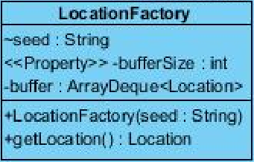

private String seed;
A copy of the seed of the player to manage randomness
This property is private because it is only intended to access by setter and getter methods provided
private int bufferSize;
A designated buffer size of buffer to manage the number of Locations to keep in the ArrayDeque
This property is private because it is only intended to access by setter and getter methods provided
private ArrayDeque<Location> buffer;
An ArrayDeque that keeps generated Locations inside. It is used as a queue in this program
This property is private because it is only intended to access by setter and getter methods provided

Constructors
public LocationFactory(String seed);
@param seed as a String to manage randomness
This will initialize the property seed with parameter seed
public void setBufferSize(int bufferSize);
@param bufferSize as a String to change buffer size according to needs
public Location getLocation();
@return newLocation
This method poll a Location from arraydeque and return it.
Public void addLocation();
This method will be called when system is idle and it will fill the arraydeque with newly generated Locations

8.public class Map
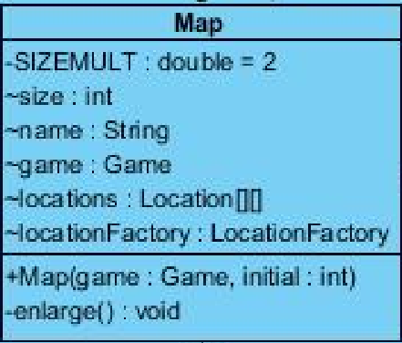
Parameters
private final double SIZEMULT = 2;
SIZEMULT is a private constant double that designates the size increase of the map when border is reached
private int size;
size is an int that shows the current size of the square map
private String name;
This property is private because it is only intended to access by setter and getter methods provided
Game game;
An instance of the game object to reach other objects in the program

private Location[][] locations;
A 2 dimensional array of Locations to represent the Map.
This property is private because it is only intended to access by setter and getter methods provided
private LocationFactory locationFactory;
A LocationFactory to generate Locations when player move

Constructors
public Map(Game game,int initial);
@param game, game object passed from the caller to make it possible to reach other objects In the program
@param initial an integer value that shows the initial size of the square 2 dimensional Location array
Constructor sets the properties with the parameters and initializes locations and LocationFactory
Methods
private void enlarge();
This method is called when player hits the borders of the existing Map, it will create a new Location[][] with the size = (size *SIZEMULT) and pass the existing locations to the middle of the new Location[][]

9.public enum Direction
Direction is enumeration that shows directions with the following constants in it
North,
East,
South,
West,
Upwards,
Downwards
10.public class Game
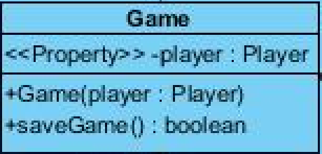
Parameters
private Player player;
An Instance of the player objects to be called from other classes that have the instance of the game object
for example game.getPlayer().go(Direction.North)
This property is private because it is only intended to access by setter and getter methods provided

Constructors
public Game( Player player);
@param player is an instance of player from caller object
Constructor sets property player with parameter player

Methods

public Player getPlayer();
@return Player
returns the player object
11.public class GameSystem
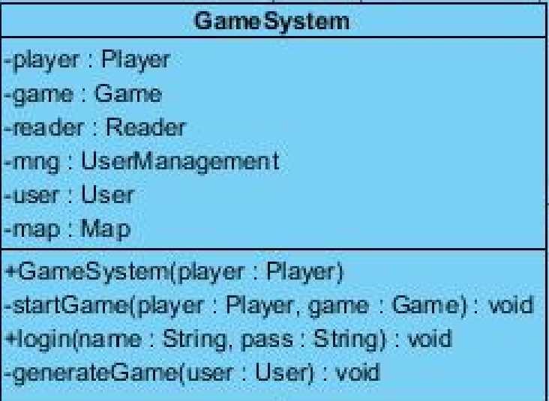
Properties
private Player player;
A player object that will be generated according to User logged in
This property is private because it is only intended to access by setter and getter methods provided
private Game game;
A Game object that will be generated according to User logged in
This property is private because it is only intended to access by setter and getter methods provided
private Reader reader;
A Reader object which will analyze the inputs of the User and call the methods of the player object
This property is private because it is only intended to access by setter and getter methods provided
private UserManagement mng;
An Object that manages the login authentications
This property is private because it is only intended to access by setter and getter methods provided
private User user;
An object that represents the user logged in and keeps its data at runtime and saves it during logout
This property is private because it is only intended to access by setter and getter methods provided
private Map map;
A Map object which player will be wandering during playtime
This property is private because it is only intended to access by setter and getter methods provided
Constructors
public GameSystem();
A constructor with no parameters will initialize the UserManagement object

Methods
private void startGame(Player player,Game game);
@param player a Player object that generated according to user data
@param game, a Game object that generated according to user data
A private method that will be called when user logs in and starts the game
public void login(String name, String pass);
@param name is a String that shows the login name of the user
@param pass is a String that shows the login password of the user
This method will take username and password and call the authentication method of the UserManagement object. If authentication is successful it will call the generateGame method.
private void generateGame(User user);
@param user the user object that authenticated
This method will load the game according to User data, if data is empty it will randomly assign a seed and generate according to that value. After loading it will start the game.
b)datamanage Package
1.public class User

Properties
private String username;
A string that indicates the login username of the User
This property is private because it is only intended to access by setter and getter methods provided
private String password;
A string that indicates the login password of the User. This can be encrypted in order to increase security
This property is private because it is only intended to access by setter and getter methods provided
private String seed;
A String, seed value that will guide randomness
This property is private because it is only intended to access by setter and getter methods provided
private String data;
A String, data which will be loaded at the startup, and will be saved during exit
This property is private because it is only intended to access by setter and getter methods provided

Constructors
public User(String username, String password);
@param username,that indicates the login username of the User
@param password,that indicates the login password of the User
This constructor sets the parameter values to property values

Methods
public String getSeed();
@return seed as a String
This is the getter Method for Property seed
public String getData();
@ return data as a String
This is getter Method for Property data
public boolean tryPassword(String pass)
@param pass a String that will be compared to password of the user
@return boolean success of the trial
This method checks if password user entered is correct

1.public class UserManagement
private Map<String,User> userMap;
public UserManagement();
This constructor takes no parameters and it fills userMap with the method getUsers()
private Map<String,User> getUsers();
@return Map<String,User> as a map of Users with names as their keys
This method reads a certain data file and fills the userMap accordingly
public boolean checkIDPassword(String id,String pass);
@param id a String that shows the id that will be tried
@param pass a String that shows the password that will be tried
@return boolean success
This method finds the user with given id and checks if pass is correct, and returns a boolean that shows the success of the authentication
public User getUser( String id);
@param id a String as the id of the User
@return User that found,null if User does not exists
This method looks for given id in the userMap and returns that user if it exists

c)UIManage package
1.public class Reader
Properties
private Game game;
A game object that will help Reader to reach other objects in the program
Constructors
public Reader(Game game)
@param game a simple constructor to set property game as parameter game
Methods
public String analyze( String input)
@param input a string input that typed by the user
@return resulting String message to print on the screen
This Method takes a string input with format action receiver tool or action direction, etc. and execute the regarding methods. After execution returns the resulting String to the caller

